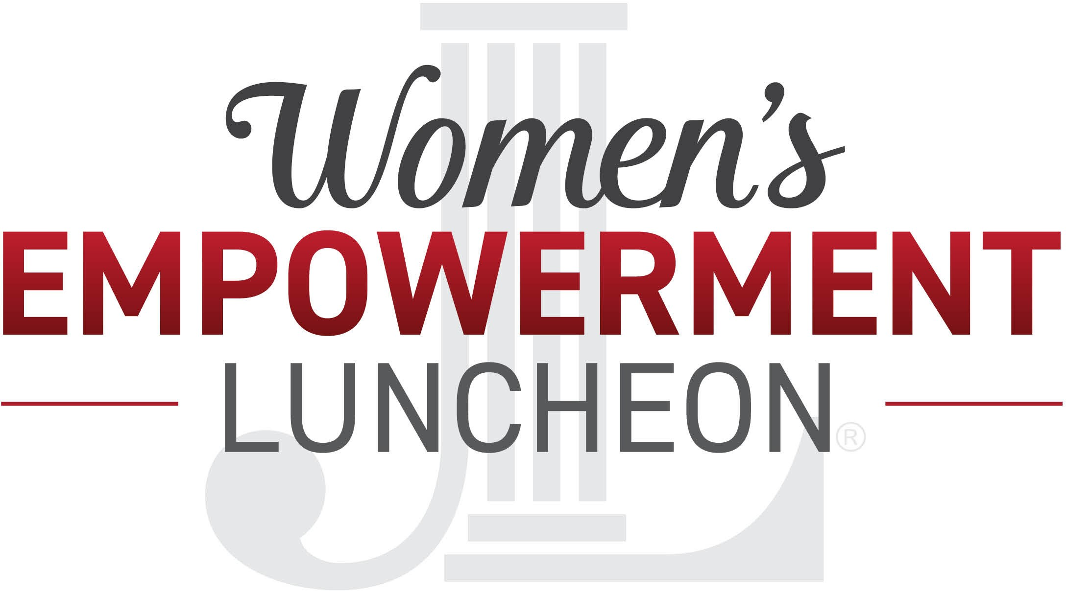

AWARD NOMINATION PACKET

2021

2021 WOMEN'S EMPOWERMENT AWARD NOMINATIONS

The Junior League of Pensacola Women’s Empowerment Awards formally recognize and celebrate the outstanding contributions of women and young ladies in the Pensacola area. These awards honor exceptional women of all ages, of diverse cultures and roles, celebrating the power of individuals to spark change and improve their community and beyond. Whether your candidate is well known or an unsung heroine, we want you to tell us the inspirational stories of women whose extraordinary achievements empower others.
Nominations are now being accepted for the following categories: WOMAN IN BUSINESS- NON-PROFIT
This award is given to a professional woman in the non-profit sector who has
been motivated and driven in her own career while maintaining a great balance of empowering herself while helping and mentoring other women in our business community.

WOMAN IN BUSINESS- FOR-PROFIT
This award is given to a professional woman in the for-profit sector who has been motivated and driven in her own career while maintaining a great balance of empowering herself while helping and mentoring other women in our business community.

WOMAN IN PHILANTHROPY
This award is given to a woman who is and remains an expert on the causes or communities they focus on. They generously donate their time and money to the causes they support.

WOMAN OF SERVICE
This award is given to a woman who is passionate about serving the community. She shows zeal, leadership, and consistently goes above and beyond in her volunteerism.

HOMETOWN HERO
This award honors a woman working in education, public service, the medical field, as a first responder, or in the military. She is a professional who makes extraordinary contributions by putting their needs aside to serve others in our community.

YOUTH WOMAN IN LEADERSHIP- HIGH SCHOOL
This award is given to a high school aged young lady or student who demonstrates exceptional leadership and service to the community.

YOUTH WOMAN IN LEADERSHIP- COLLEGE
This award is given to a college-aged young lady or student who demonstrates exceptional leadership and service to the community.

MARY RAINE HILL
This award is named after the first president of the Junior League of Pensacola and is given to a woman who has a long-standing record of dedication to the league and also exemplifies what it means to empower other women in the community.

NOMINEES WILL BE EVALUATED ON:
Her involvement & commitment to the community; the scope & impact of her service.
Her leadership, mentorship and efforts to help advance others.
Her accomplishments within her profession, industry, field/area of interest

Nominees will be notified and sent an application to complete for further consideration.

Contact empowerment@juniorleagueofpensacola.org with questions.

The luncheon will be held on Friday, March 5th 2021 at Pensacola Country Club Nominations close on January 9, 2021

To submit your nomination, please complete next page to email or mail to:

empowerment@juniorleagueofpensacola.org OR
Junior League of Pensacola
ATTN: Women's Empowerment Committee 2016 West Garden Street
Pensacola, FL 32502

YOUR FULL NAME:

YOUR EMAIL ADDRESS:

NOMINEE'S FULL NAME:

NOMINEE'S EMAIL ADDRESS:

WHAT CATEGORY ARE YOU NOMINATING FOR?
Woman in Business: Non-Profit Woman in Business: For-Profit Woman in Philanthropy
Woman of Service Hometown Hero
Youth Woman in Leadership: High School Youth Woman in Leadership: College Mary Raine Hill

BRIEFLY EXPLAIN IN 250 WORDS OR LESS WHY YOU THINK THIS PERSON DESERVES TO BE NOMINATED:

